

Knowledge Organiser Hockey Y3 and Y4

Ladder Knowledge
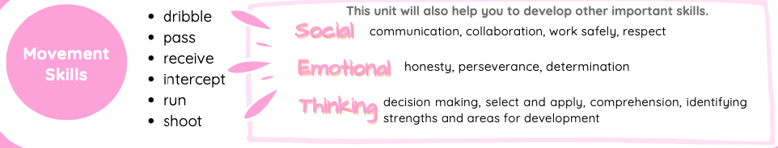
Sending & receiving:
Year 3: point your stick to your target when sending the ball to help to send it accurately.
Dribbling:
Year 3: dribbling is an attacking skill which helps you to move towards a goal or away from defenders.
Space:
Year 3: spreading out as a team will help to move the defenders away from each other.
Attacking and defending:
Year 3: as an attacker you need to maintain possession and score goals. As a
Attacking and defending:
Year 4: as an attacker shoot when close to goal or if there is a clear path. Pass when a teammate is

Year 4: cushioning
Year 4: using changes of
Year 4: moving into defender you need
free and in good space. As

About this Unit
the ball will help you to control it when receiving it.
direction and speed when you dribble will help you to maintain possession.
space will help your team keep possession and score goals.
to stop the opposition and gain possession.
a defender mark a player
to stop them from being an option. Try to intercept the ball as it is passed.

Hockey is an invasion game. An invasion game is a game where two teams play against each other. You invade (enter) the other team's space to try to score goals.

The name 'hockey' is thought to come from a French word 'hoquet' which means 'shepherd’s stave'. Stick and ball games can be traced back thousands of years to ancient civilisations in China, Persia, Egypt and Greece.

In modern times, there are different versions of hockey, these include field hockey, ice hockey, roller hockey, and indoor hockey.

Field hockey first appeared in the Olympics in 1908 in London.

Movement Skills
dribble pass receive intercept run shoot

This unit will also help you to develop other important skills.
comTmhiusnuicnaittiownil,lcaollslaobhoerlaptioyno,uwtoorkdesavfeelloyp, roetshpeerctimportant skills.
Sociiialll
Emotiiionalll Thiiinkiiing

honesty, perseverance, determination

decision making, select and apply, comprehension, identifying strengths and areas for development

Invasion Games Key Principles
attacking defending

Rules

Feet:
You cannot kick the ball. Try not to let the ball touch your feet. If feet are intentionally used, a free pass is awarded.

Sticks:
The stick cannot be lifted higher than waist height, and you can only use the flat side.
You cannot intentionally interfere with another person's stick. If these rules are broken, a free pass is awarded.

Free pass:
If a rule is broken, a free pass is awarded to the other team.
All players must be three big steps away from the person taking the free pass.

score goals create space

maintain

stop goals

deny space

Tactics
Using tactics will help your team to maintain possession and score goals or deny space, gain possession and stop goals..
Throws must be taken from behind a throw line.
Throws are measured from the throw line to where the object first lands.
Home Learning
Make sure any unused equipment

possession

move the ball towards goal
gain possession
Can you think of any other invasion games that share these principles?

Healthy Participation
is stored in a safe place.
Don't lift your stick higher than your waist.
Ensure you are working in a safe space away from others.
Find more games that develop these skills in the Home Learning Active Families tab on www.getset4education.co.uk


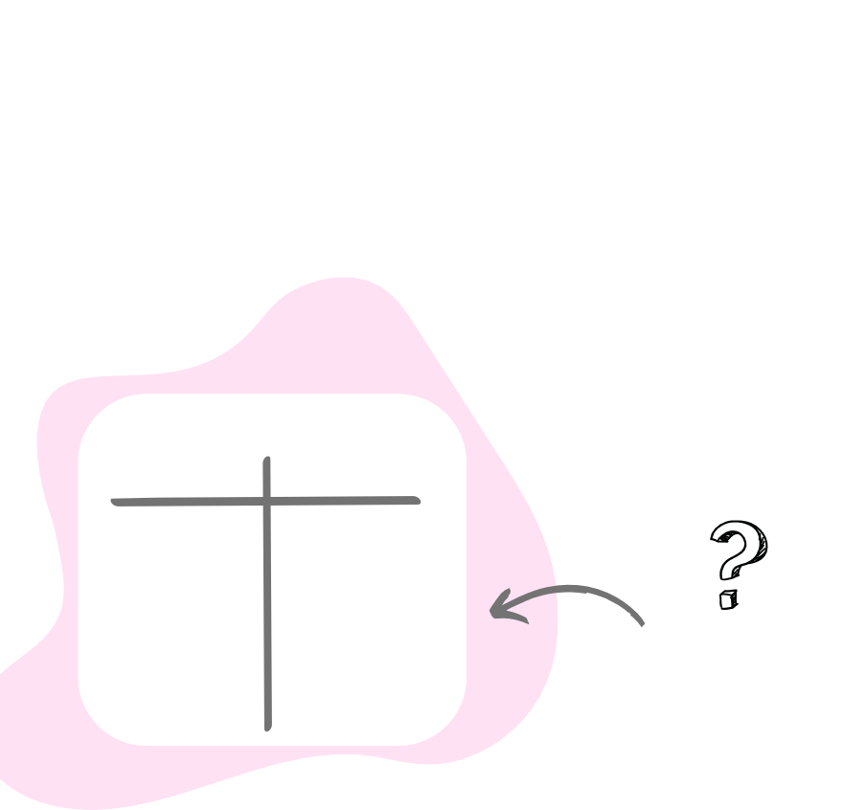
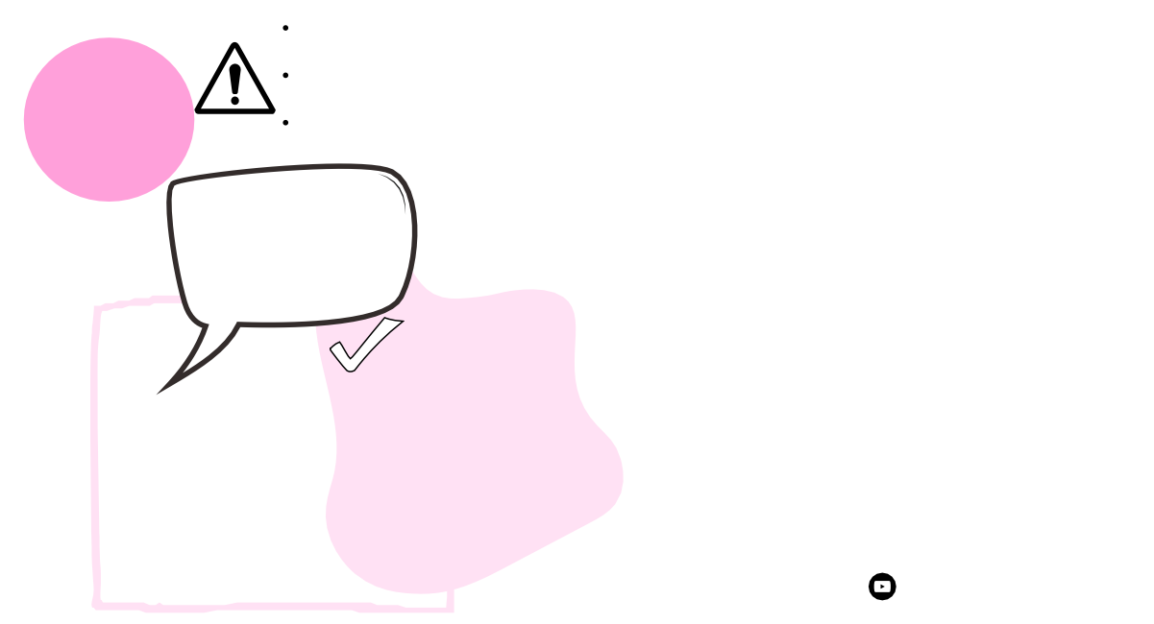

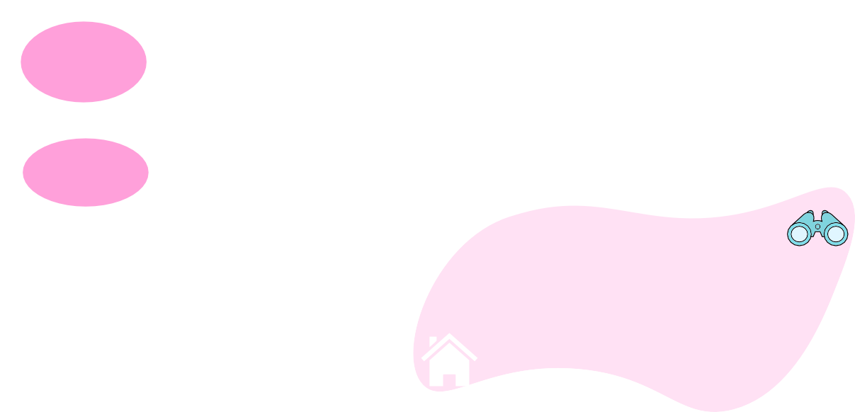
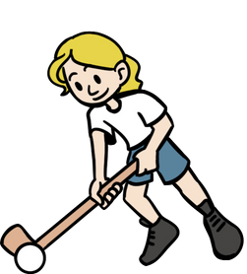
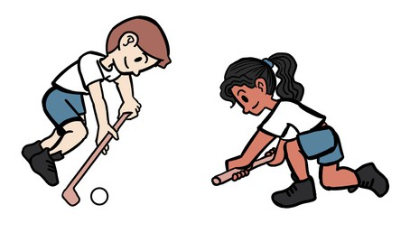
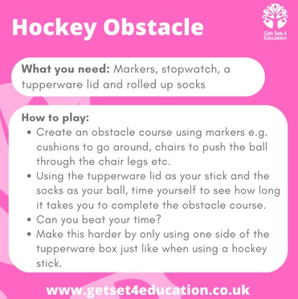

Key Vocabulary
accelerate: speed up

control: being able to perform a skill with good technique
cushion: take the power out of an object
decision: select an outcome delay: to slow an object or player gain: get possession of the ball

invasion: a game of two teams who invade each other's space to score goals
opposition: the other team option: possible choices possession: to have
receive: to collect or stop a ball that is sent to you referee: the person who makes sure the rules are followed tackle: to stop an opposing player with the ball tournament: a competition of more than two teams

Copyright Get Set 4 Education Ltd.

If you enjoy this unit why not see if there is a hockey club in your local area.

How will this unit help your body?
agility, balance,
co-ordination, speed, stamina

Head to our youtube channel to watch the skills videos for this unit.

@getset4education136

