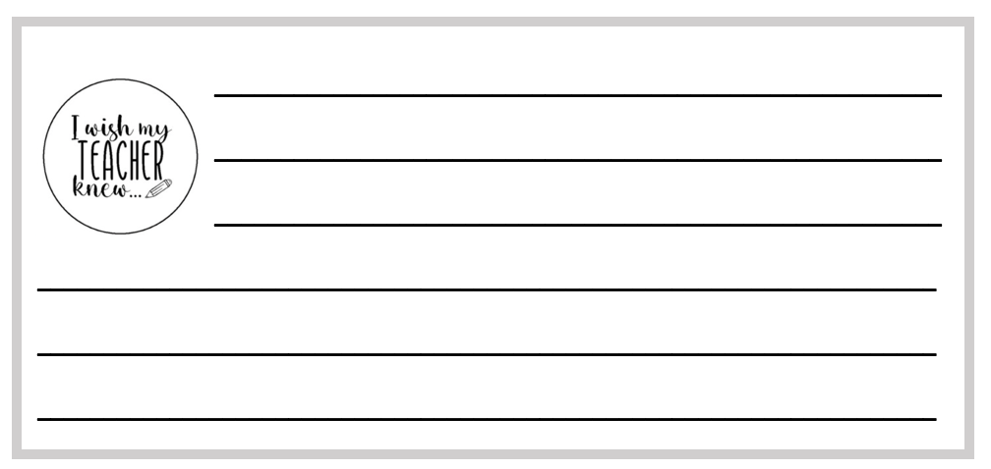

I WISH my teacher knew…

Write a note to your teacher and place it into the jar when you come into class if:
- Something has happened which you want them to know about.
- You are finding something difficult and would like help.
- You have a particular feeling that you think they should know.
- You need help with anything.

