Earth and Space-Earth and Beyond

Key Vocabulary

Term | Information
Axis | An imaginary line about which a body rotates
Asteroid | A small rocky body orbiting the sun
British summer time – (BST) | Time as advanced one hour ahead of Greenwich mean time for daylight saving in the uk between march and October.
Galaxy | A system of millions or billions of stars, together with gas and dust, held together by gravitational attraction
Crescent | The curved sickle shape of the waxing or waning moon
Moon | The natural satellite of the earth, visible (chiefly at night) by reflected light from the sun
Lunar moon | A lunar eclipse occurs when the Moon passes directly behind the Earth into its umbra (shadow)
Nebula | A cloud of gas and dust in outer space.
Solar system | The collection of eight planets and their moons in orbit round the sun, together with smaller bodies in the form of asteroids, meteoroids, and comets.
Star | A fixed luminous point in the night sky which is a large, remote incandescent body like the sun.
Sun | The star round which the earth orbits.
Year | The period of 365 days (or 366 days in leap years) starting from the first of January.

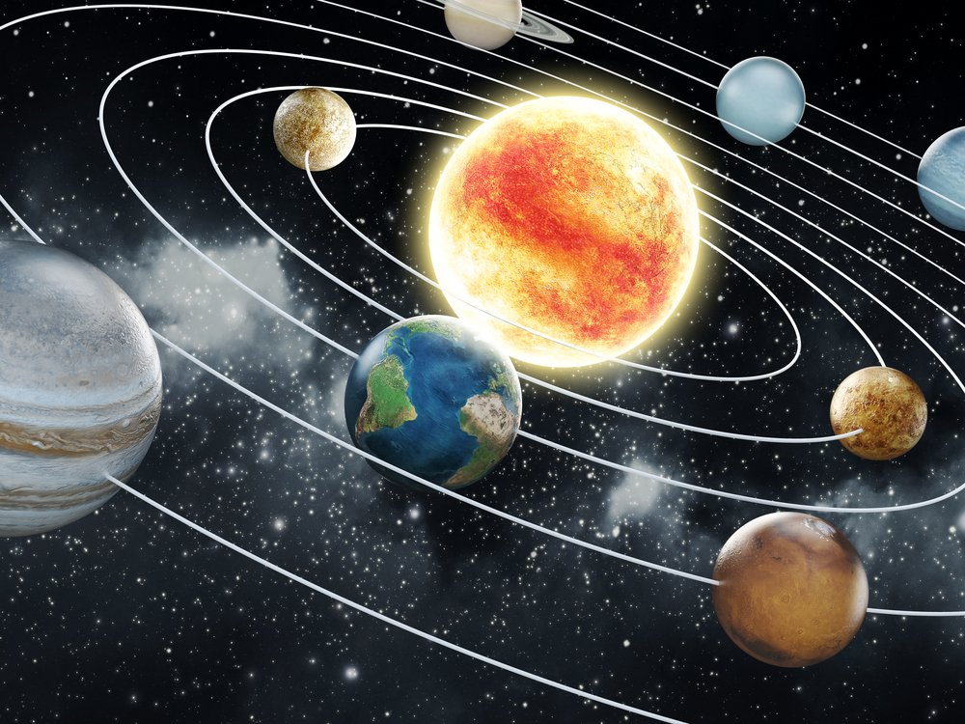

Planet | Information
Mercury | Mercury is the smallest and innermost planet in the Solar System.
Venus | Venus is the second planet from the Sun, orbiting it every 224.7 Earth days.
Earth | The planet on which we live; the world
Mars | Mars is the fourth planet from the Sun and the second-smallest planet in the Solar System after Mercury.
Jupiter | The largest planet in the solar system; the fifth major planet from the sun.
Saturn | Saturn is the sixth planet from the Sun and the second-largest in the Solar System, after Jupiter.
Uranus | The planet seventh in order from the sun.
Neptune | A giant planet with a ring of ice particles; the 8th planet from the sun.

